**28 April Home questions**

#1.WAP to reads a sentence and prints frequency of each of the vowels and

total count of Consonants.

Code:

#include <stdio.h>

#include <string.h>

int main()

{

    int i,j,n,counta_285=0,counte_285=0,counti_285=0,counto_285=0,countu_285=0,space_285,sum_285,temp_285;

    char A_285[100];

    printf("Please provide a short sentence\n");

    gets(A_285);

    n=strlen(A_285);

    for(i=0;i<n;i++)

    {

        if(A_285[i]=='A' || A_285[i]=='a')

        {

            counta_285++;

        }

        else if(A_285[i]=='E' || A_285[i]=='e')

        {

            counte_285++;

        }

        else if(A_285[i]=='i' || A_285[i]=='I')

        {

            counti_285++;

        }

        else if(A_285[i]=='O' || A_285[i]=='o')

        {

            counto_285++;

        }

        else if(A_285[i]=='U' || A_285[i]=='u')

        {

            countu_285++;

        }

        else if(A_285[i]==' ')

        {

            space_285++;

        }

    }

    printf("frequency of 'A' or 'a' is %d\n",counta_285);

    printf("frequency of 'E' or 'e' is %d\n",counte_285);

    printf("frequency of 'I' or 'i' is %d\n",counti_285);

    printf("frequency of 'O' or 'o' is %d\n",counto_285);

    printf("frequency of 'U' or 'u' is %d\n",countu_285);

    sum_285= counta_285+counte_285+counti_285+counto_285+countu_285+space_285;

    temp_285=n-sum_285;

    printf("The number of the consonants in your sentence is %d ",temp_285);

    return 0;

}

Output:

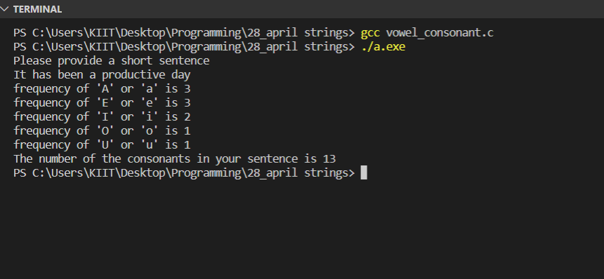

#2.Write a program to concatenate two strings without using any library

function.

Code:

#include <stdio.h>

#include <string.h>

int main()

{

    int i_285,j_285,n_285,temp_285;

    char A_285[50], B_285[20];

    printf("Please give your first sentence\n");

    gets(A_285);

    printf("Please give your second sentence\n");

    gets(B_285);

    n_285= strlen(A_285);

    temp_285=0;

    for(i_285=n_285;i_285<49;i_285++)

    {

        A_285[i_285]=B_285[temp_285];

        temp_285++;

    }

    printf("after concatenating....\n");

    puts(A_285);

    return 0;

}

Output:

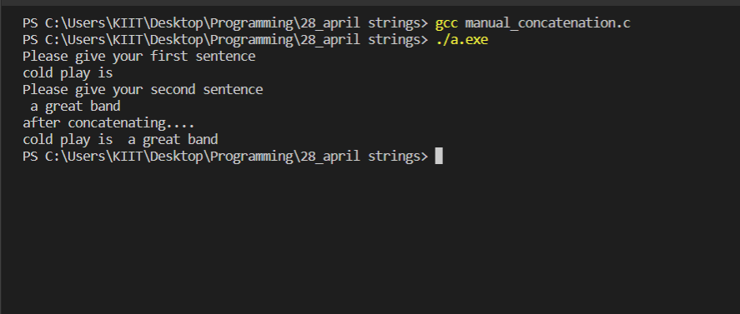

#3.WAP to take a sentence as input and reverse every word of the sentence.

Code:

#include <stdio.h>

#include <string.h>

int main()

{

    int i_285,j_285,n_285;

    char A_285[3][30];

    printf("Please provide a sentence\n");

    for(i_285=0;i_285<3;i_285++)

    {

        scanf("%s",A_285[i_285]);

    }

    for(i_285=0;i_285<3;i_285++)

    {

        n_285=strlen(A_285[i_285]);

        for(j_285=(n_285-1);j_285>=0;j_285--)

        {

            printf("%c",A_285[i_285][j_285]);

        }

        printf(" ");

    }

}

Output:

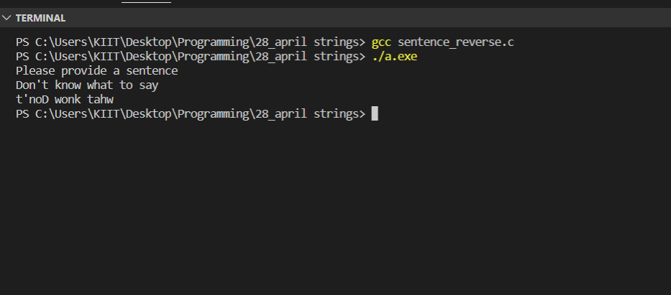

#4.WAP to replace all occurrences of a substring in a given string with a new

one. [substring= a smaller portion of the string]

Code:

#include <stdio.h>

#include <string.h>

int main()

{

    int i,j;

    char A_285[5][30], ostr_285[10],nstr_285[10];

    printf("Please provide a sentence\n");

    for(i=0;i<5;i++)

    {

        scanf("%s",A_285[i]);

    }

    printf("give old word\n");

    scanf(" %s",&ostr_285);

    printf("give new word\n");

    scanf(" %s",&nstr_285);

    for(i=0;i<5;i++)

    {

        if(strcmp(A_285[i],ostr_285)==0)

        {

            strcpy(A_285[i],nstr_285);

            break;

        }

    }

    printf("Your new sentence is as follows=>\n");

    for(i=0;i<5;i++)

    {

        printf("%s",A_285[i]);

        printf(" ");

    }

    return 0;

}

Output:

